

MATHEMATICS
APPLICATIONS

Test 7 – Directed Graphs and Networks

Chapter 9
Semester 2 2018

Calculator Assumed

Time allowed
Working time for this section: 20 minutes
Marks available: 19 marks

Material required/recommended for this section

To be provided by the supervisor
This Question/Answer booklet
Formula sheet

To be provided by the candidate
Standard items: pens, pencils, pencil sharpener, eraser, correction fluid, ruler, highlighters

Special items: drawing instruments, templates, notes on one unfolded sheet of A4 paper, and up to three calculators satisfying the conditions set by the Curriculum Council for this course.

Important note to candidates
No other items may be used in this section of the examination. It is your responsibility to ensure that you do not have any unauthorised notes or other items of a non-personal nature in the examination room. If you have any unauthorised material with you, hand it to the supervisor before reading any further.
- (6 marks)
Calculate the earliest starting times and the latest starting times for each activity in the network below. Activity times shown are in hours.

- (3 marks)
Determine the critical path and the project completion time for the following network. Activity times shown are in days.
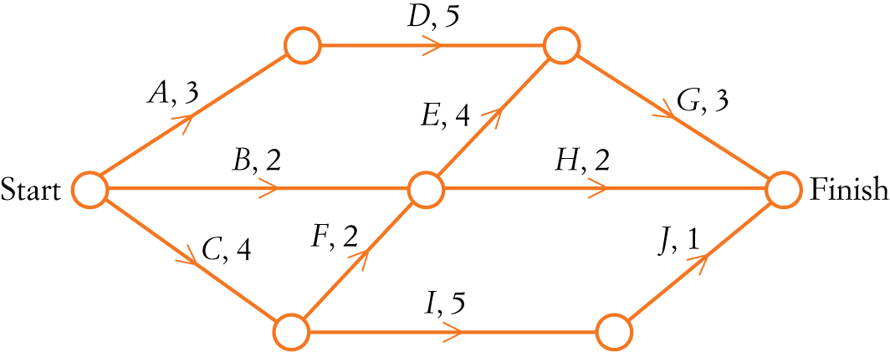

- (10 marks)
A furniture store must arrange deliveries to four customers. The store contracts its deliveries to four different drivers. The distance in kilometres that each driver will need to travel to complete the deliveries is shown in the table below.
 | Driver 1 | Driver 2 | Driver 3 | Driver 4
Customer A | 17 | 22 | 17 | 19
Customer B | 19 | 20 | 20 | 17
Customer C | 21 | 24 | 23 | 18
Customer D | 21 | 18 | 20 | 19
The deliveries will be allocated in order to minimise the total distance that must be travelled. The Hungarian algorithm is to be used to ﬁnd this minimum value.
- Step 1 of the Hungarian algorithm is to subtract the minimum entry in each row from each element in the row.
Complete step 1 for Customer C by writing the missing values in the table below. [2]
 | Driver 1 | Driver 2 | Driver 3 | Driver 4
Customer A | 0 | 5 | 0 | 2
Customer B | 2 | 3 | 3 | 0
Customer C
Customer D | 3 | 0 | 2 | 1

- Complete the Hungarian algorithm so that an allocation can be made. [3]

- Draw the bipartite graph for the final matrix. [2]

- Determine the allocation of drivers to customers. [2]

- Find the total distance travelled by the drivers. [1]

End of Test

Additional working space
Question number: ______

